ASSIGNMENT - DIGITAL MARKETING

|  |  |
| --- | --- |
| Reg No | 962820106027 |
| NAME | PRIYA DHARSHINI N |
| NM ID | 9EBBF60AF87580AA35F4683CFE8C95AE |
| Date | 22-10-2023 |

1.Create a blog or website using Blogspot and WordPress. Customize the theme design and post new article with 500 words.

Link: <https://www.blogger.com/u/1/blog/posts/6441217497410719364?pli=1>

<https://tastyswirls.blogspot.com/>

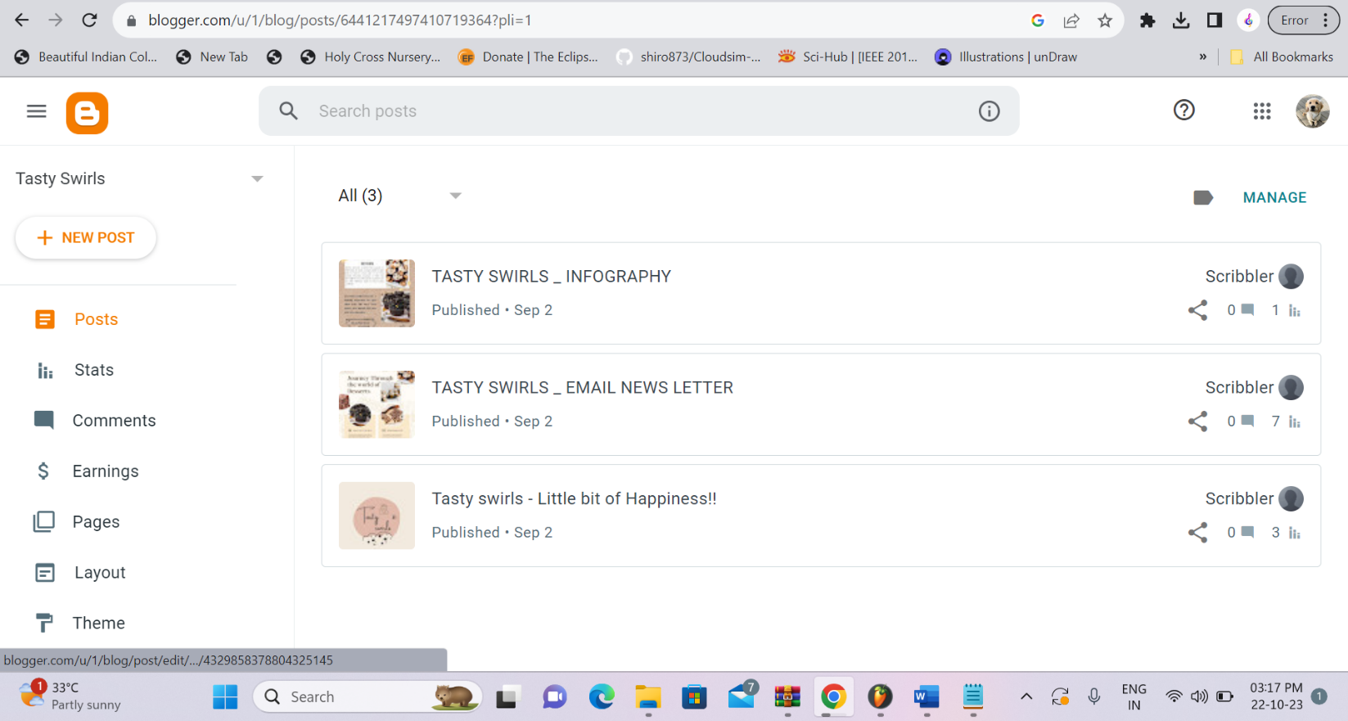

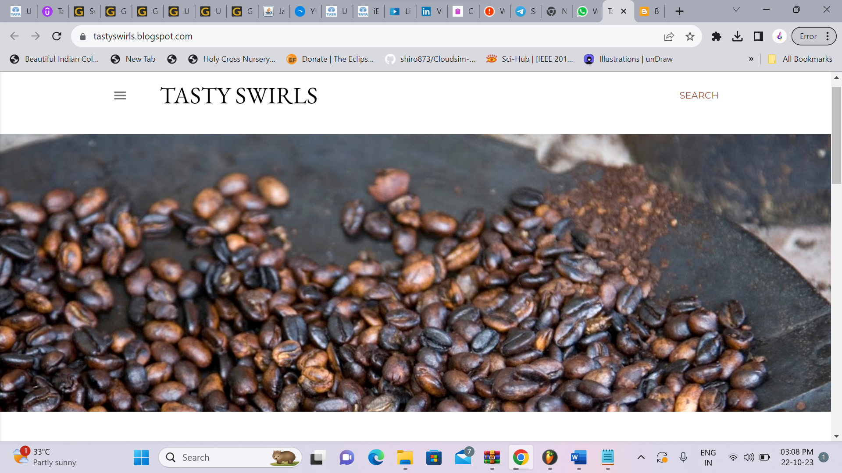

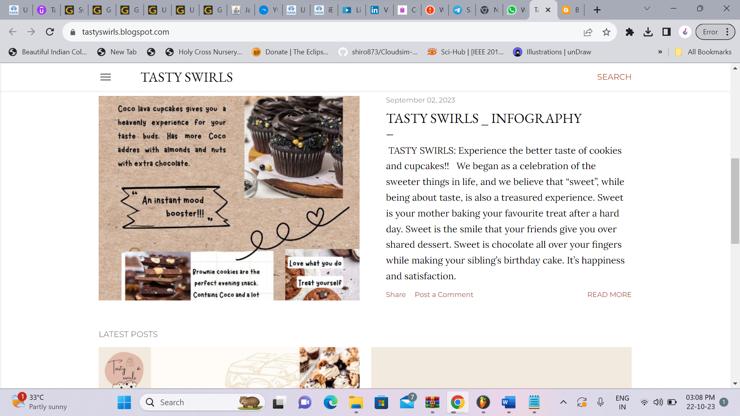

**2**.Create a new facebook page and post one social media poster for your brand.

Link: <https://www.facebook.com/profile.php?id=61550069293344>

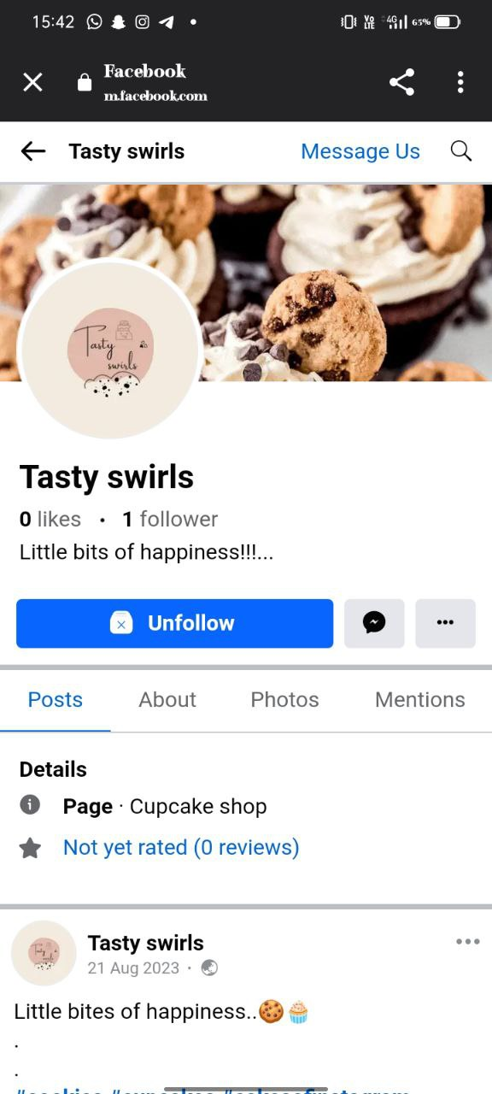

**3**.Create and design a social media advertisement poster using canva

Link: <https://www.canva.com/design/DAFtUDJC8uE/IAm0FJcr-j5Qsbcbbazf_A/edit?utm_content=DAFtUDJC8uE&utm_campaign=designshare&utm_medium=link2&utm_source=sharebutton>

 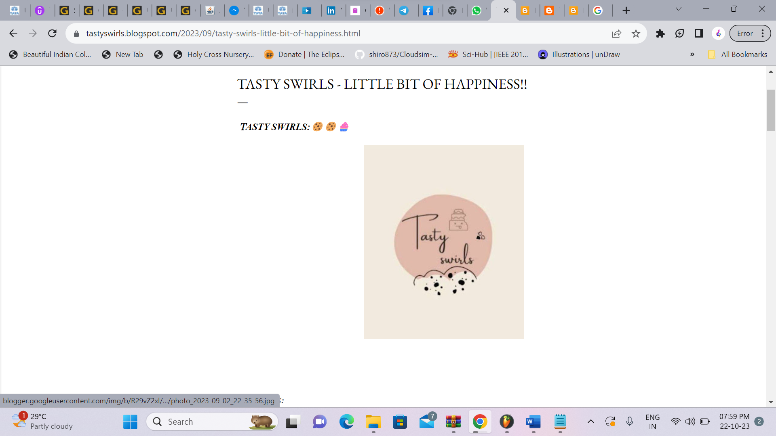

4.Create email newsletter design using MailChimp or canva tool.

Link: <https://www.canva.com/design/DAFtT7RFLDM/uuoqGPCdPDkV5SbiUfTmSQ/edit?utm_content=DAFtT7RFLDM&utm_campaign=designshare&utm_medium=link2&utm_source=sharebutton>

